
THIAGARAJAR COLLEGE OF ENGINEERING
(A Govt. Aided Autonomous Institution Affiliated to Anna University)
Madurai 625 015
CONTINUOUS ASSESSMENT TEST
CAT No.:I
Academic year 2025-2026 (Odd semester)
Name of the student: |  |  |  |  |  |  |  | Reg. No:
Course Code | 22CSPH0 | Course Name |  | Cross Platform Mobile Application Development
Degree | B.E. | Branch | CSE |  | Semester |  | V |  | Duration | 1 Hr.45 Min
Day & Date | 21.08.2025(Thursday) |  | Session : II |  |  |  |  |  | Max. Marks | 60 / 60
Faculty in-Charge |  |  | Dr.Raja Lavanya
COURSE OUTCOMES & ASSESSMENT PATTERN FOR THIS TEST
CO No. | Course Outcomes | TPS levels | Marks
CO1 | Apply the fundamentals of Native and Hybrid Mobile application requirements for a chosen application. | TPS3 | 15
CO2 | Adapt the Dart Programming functionalities such as OOPs and Collections for handling user interface in Flutter Applications. | TPS3 | 24
CO3 | Apply the Flutter User Interface such as Widgets, Layout and Gestures with each stage of App state Management. | TPS3 | 21
SPECIAL INSTRUCTIONS: Students are permitted to use the following: NIL

Answer All Questions
Part A (9 marks) |  | Marks | CO
 | List the components of Flutter architecture. | 3 | CO1
 | Cite the difference between List, Set, and Map in Dart collections. | 3 | CO2
 | Describe the steps to create and display the calendar using flutter. | 3 | CO3

Part B (9 marks) |  | Marks | CO
 | Explain the concept of event-driven programming in mobile apps. | 3 | CO1
 | Define the data types available in Dart. | 3 | CO2
 | Describe briefly about the types of visible widgets with example. | 3 | CO3

Part C (42 marks) |  | Marks | CO
C1. | Illustrate the classification of the following mobile applications as Native, Hybrid, or Cross-platform. Justify the classification based on their development approach, tools or technologies and the target platforms they support.  Applications to illustrate:  a) WhatsApp  b) Instagram  c) Uber  d) Flipkart  e) Google Maps  f) Facebook Ads Manager  g) Microsoft Teams | 9 | CO1
 | (OR)
C2. | Demonstrate a news app using Android Architecture Components to support real-time updates, offline reading, and clean data flow. Explain how each component contributes to performance, data persistence, and UI responsiveness. | 9 | CO1
C3. | i)Write a Dart program that uses two sets: one for a list of registered students and another for students who submitted an assignment. Perform set operations to:  - Find students who submitted  - Find students who didn’t submit  - Display the total count of submitted and not submitted students  ii)Develop a Dart program that stores product names and their prices using a Map<String, double>.  - Add at least five items  - Update the price of an existing item  - Display all items and calculate the total inventory value  iii)Create a Dart program with a function named generateMultiplicationTable(int n).  - Use a for loop to print the multiplication table of the given number up to 10  - Call this function from main() with user-defined input | 18 | CO2
 | (OR)
C4. | i)Use a Dart class structure for a shopping cart system using Product, CartItem, and Cart classes. Demonstrate aggregation by associating products with cart items, and implement key methods such as addItem(), displayCart(), and checkout() in the Cart class.  ii)Apply constructor overloading and polymorphism in the shopping cart system. Include a base class Item and a derived class Product that overrides a method (e.g., displayDetails()) and includes both default and parameterized constructors.  iii)Demonstrate object interactions and method calls by writing a main() function that creates product instances, adds them to a cart, and prints the cart summary with total cost. Identify the use of appropriate object-oriented programming principles like encapsulation and modularity. | 18 | CO2
C5. | A planner app is to be developed using Flutter. The app should allow users to add, view, and mark tasks as completed. Demonstrate the code for developing the flutter application:  a) Design the UI using Scaffold, AppBar, ListView, and Container to display a list of tasks.  b) Add interactivity using TextField, FloatingActionButton, and maintain the list of tasks using setState().  c) Implement a checkbox toggle for each task and apply a strike-through style when a task is marked as completed. | 15 | CO3
 | (OR)
C6. | Apply gesture controls using Flutter to improve user interaction for the given page. Demontsrate the code for developing the flutter application:  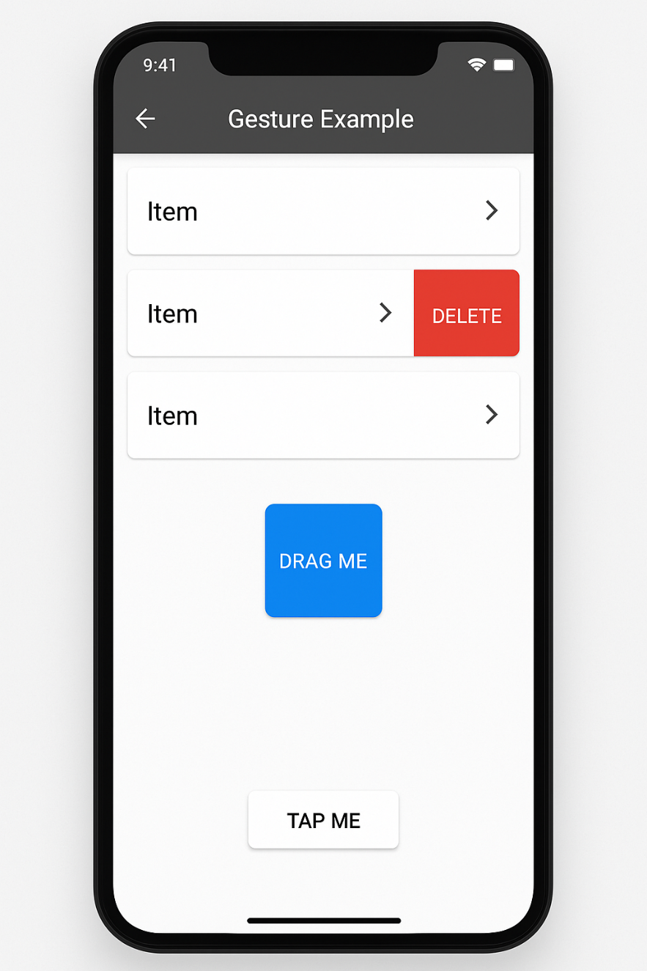 | 15 | CO3

